**Image classification via Resnet, Capsnet, CNN and Regression**

Report submitted in partial fulfilment of the requirement for the degree of

Bachelor of Technology

In

Computer Science & Engineering

By

**Jatin Bindra**

CSE-1, 4th Year



Maharaja Surajmal Institute of Technology

Affilated to Guru Gobind Singh Indraprastha University

Janakpuri, New Delhi-58

**(2016-2020)**

**Certificate**

I declare that the project “**Image classification via Resnet, Capsnet, CNN and Regression**” is uniquely prepared by me after completion of 6 weeks internship at **Indian Institute of Information Technology (IIIT-Allahabad))** in partial fulfilment of the requirement for the award of the degree of B.Tech in Computer Science and Engineering. It is a bonafide project work carried out by me under the guidance of **Dr. Mohammed Javed**(Assistant Professor, Department of Information Technology (IT), Indian Institute of Information Technology (IIIT-Allahabad)) and **Mr. Rajesh** (Research Scholar, Department of Information Technology (IT), Indian Institute of Information Technology (IIIT-Allahabad)). I further declare that work reported in this project has not been submitted and will not be submitted either in part or in full for the award of any further degree or diploma in this institute or any other institute or university.

**Mr. Jatin Bindra**

**CSE-1, 4th Year**

**20615002716**

**CerTIFICATE FROM ORGANISATION**

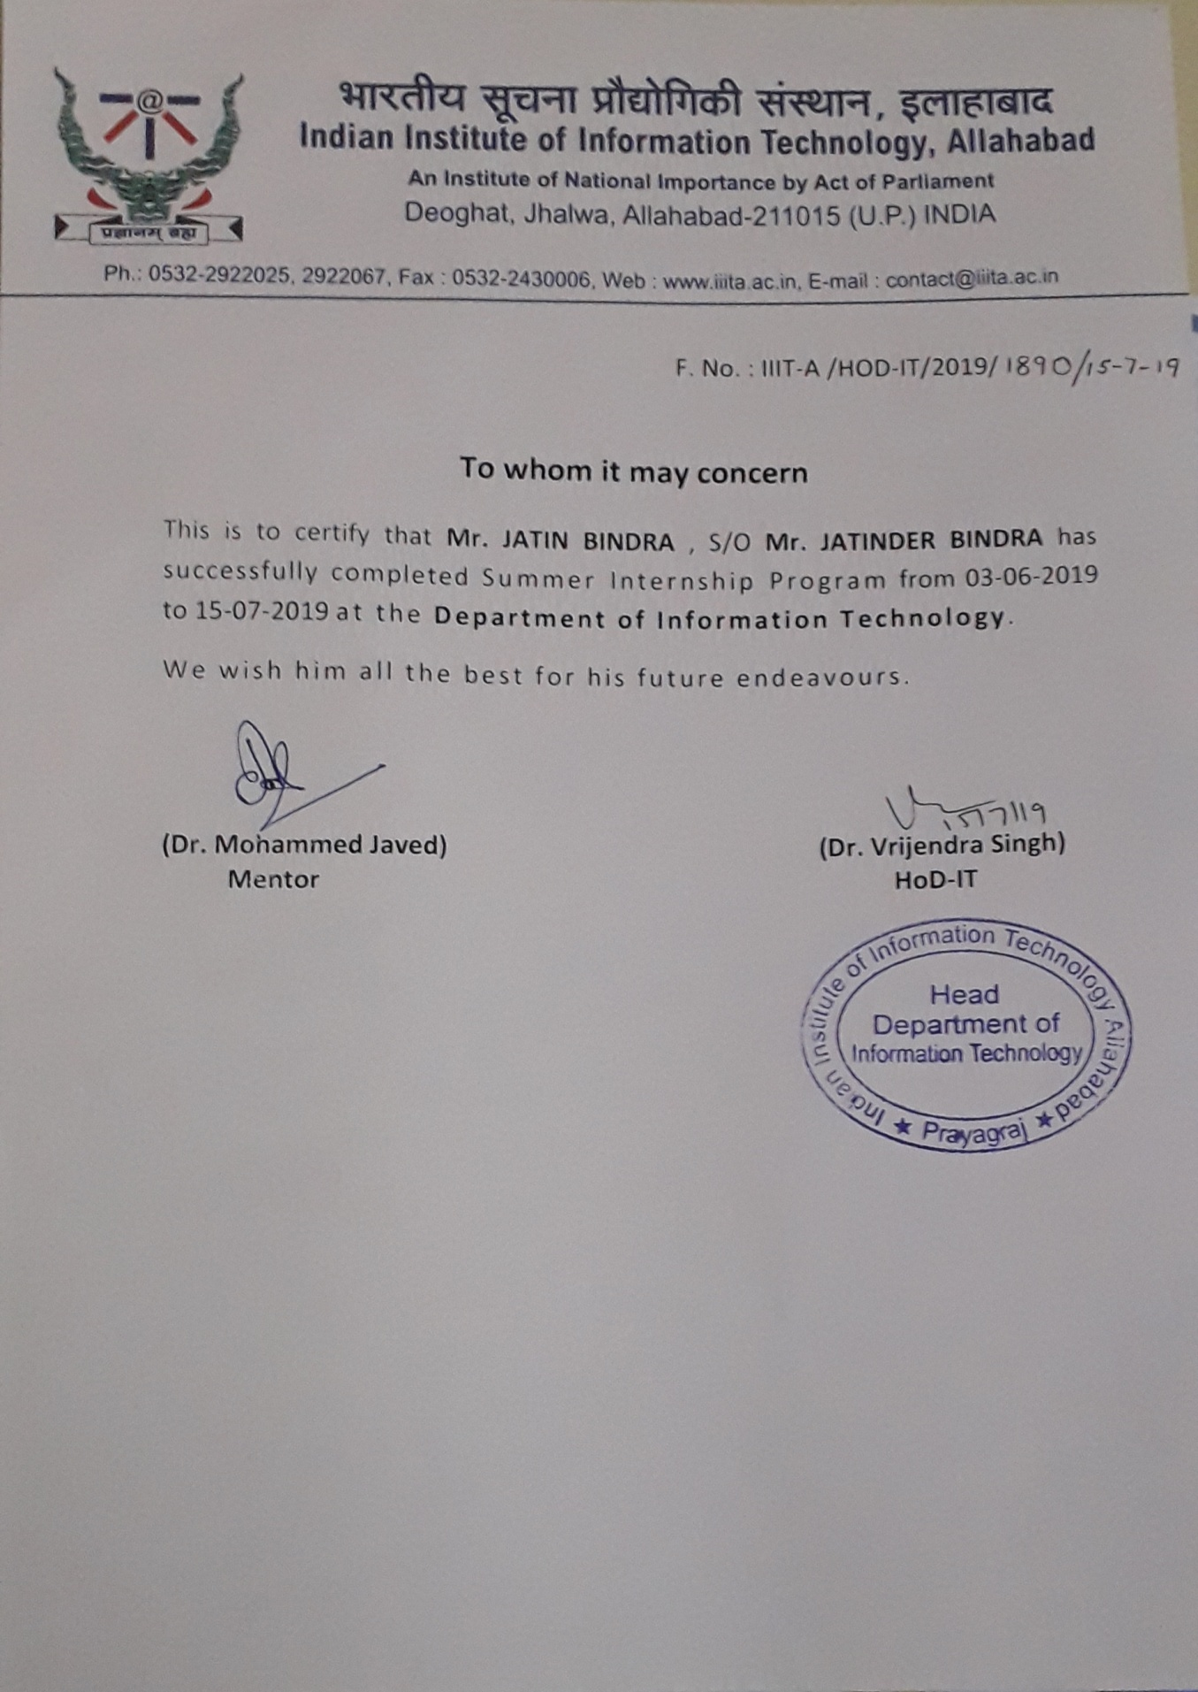

**ACKNOWLEDGEMENT**

I would like to thank **Dr. Mohammed Javed** and **Mr. Rajesh** for their valuable time and efforts for giving me the opportunity to work on this project.

I would like to thank all my colleagues, PhD scholars of Computer Vision and Biometrics Lab, Security guard and other staff members for providing me with the opportunity and facilities including the internet connection and workspace to work on the Research project.

I am extremely grateful to our respected Director, **Prof. K.P. Chaudhary**, respected Head of the Department **Dr. Koyel Datta Gupta and all other Professors of CSE Department** for encouragement, overall guidance in viewing this project a good asset and effort in bringing out this project.

**ABSTRACT**

Inspired by the deep learning models for image classification, in this paper we propose a Deep residual network and a comparison study for image classification using state of the art models. We tested the models on two datasets which include MNIST and Fashion MNIST. Both the datasets have 60000 training samples and 10000 testing samples. The datasets consists of 28X28 grayscale images. Image classification was performed on state of the art models which includes convolutional neural networks (CNNs), Capsule Network(Capsnet), and regression model(logistic regression). We got 98.49% accuracy on MNIST and 87.29% on fashion MNIST using Resnet. Finally, we compare our result with the accuracy of above mentioned models and some other state of the art models.

**TABLE OF CONTENTS**

**CANDIDATE’S DECLARATION** ii

**CERTIFICATE OF INTERNSHIP**  iii

**ACKNOWLEDGEMENT** iv

**ABSTRACT** v

**TABLE OF CONTENTS** vi

**LIST OF FIGURES AND TABLES** vii

**1. Chapter 1: Introduction 1**

1.1 Introduction

1.2 Need and Objective

1.3 Methodology

1.4 Software and Hardware Requirements

1.5 About the Organization

**2. Chapter 2: Project Design 8**

2.1Software Development Life Cycle

2.2Feasibility Study

2.3 Software Requirement and Analysis

2.4 Designing a System

2.5 ER Diagram

**3. Chapter 3: Implementation 15**

3.1 Database and File Design

**4. Chapter 4: Result and Discussion**

**5. Chapter 5: Conclusions and Future Scope**

**6. Bibliography**

**LIST OF FIGURES**

**Figure 1:** Resnet network

**Figure 2**: IIIT-A Logo

**Figure 3**: Accuracy of Resnet, Capsnet, CNN and Regression

**Figure 4**: Comparison of different ML models

**CHAPTER-1**

**Introduction**

* 1. **Introduction**

This work represents four models. The overall structure of our deep residual network consists of 12 layers with 2 jump connections. We used four such structures connected to each other to form a bigger model. The Logistic regression is used with 2000 iterations for the algorithm to converge. The CNN is used with 13 layers to form a deep neural network for classification. Finally, the data is tested with Capsnet network. Then compared all the models on MNIST dataset and Fashion MNIST dataset by calculating the accuracy of each model on these two datasets.

**1.2 Need and Objective**

With the advancement of technology the images are generated and shared at a very large scale. Because of its increasing significance, bringing up deeper models and improving the classification can have major impact in computer vision. It might be possible that one algorithm is performing better for one use case and one for another use case. Thus, it is also important to compare different algorithms on different datasets.

To use of deep Resnet neural network, Convolutional neural network, Capsule network and logistic regression for image classification.

**1.3 Methodology**

1.3.1) Image classification using Regression

1.3.2) Image classification using CNN

1.3.3) Image classification using Resnet(developed from scratch in tensorflow)

1.3.4) Image classification using capsnet

**1.3.1) Image classification using Regression**

In regression we are using Logistic regression to classify the images.

We are using the logistic regression from Sklearn and fitting the model on MNIST dataset.

**1.3.2) Image classification using CNN**

A sequential model in Keras was made to use CNN. Two dense layer were used along with adam optimizer.

Relu function is used as activation function.

10 epocs were used with a batch size of 200

**1.3.3) Image classification using Resnet**

The Resnet introduced in the paper has 5 layers: Convolutional, Batch normalization, Prelu, Convolutional, Batch normalization and last layer is addition of first and second-last making it Resnet.

Our proposed model has 8 layers: Batch normalization, Convolutional, Batch normalization, Convolutional, prelu, Convolutional, Batch normalization, Convolutional and last year is addition of first and second last.

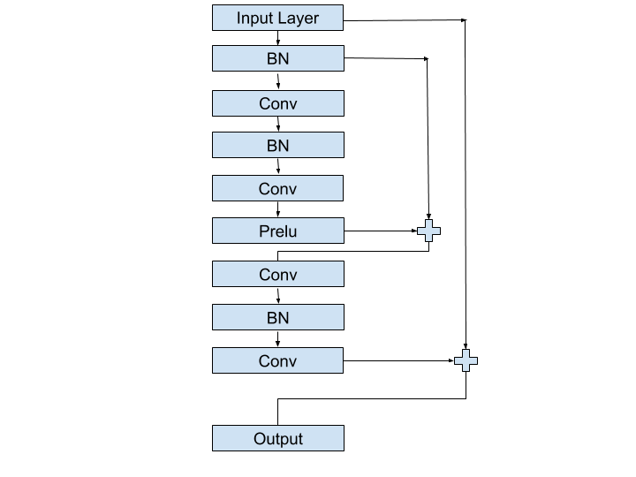

**Fig.1**

**1.3.4) Image classification using Capsnet**

Capsule network is last state-of-the-art model on MNIST dataset.

To be more prices, a capsule can be considered as a group of neurons. Activity vector of capsule exposes instantiation parameters of a particular entity type. They might be a part of a whole object or an object whole.

**1.4) Software and Hardware Requirements**

##### **1.4.1)** Python 3.0 (a.k.a. "Python 3000" or "Py3k") is a new version of the language that is incompatible with the 2.x line of releases. The language is mostly the same, but many details, especially how built-in objects like dictionaries and strings work, have changed considerably, and a lot of deprecated features have finally been removed. Also, the standard library has been reorganized in a few prominent places.

##### **1.4.2)** Anaconda Enterprise supports your organization no matter the size, easily scaling from a single user on one laptop to thousands of machines.

**1.4.3)**  **Hardware Used:-**

* Main Processor Core I5
* Hard-disk Capacity 1 TB
* RAM 8 GB
* Clock Speed 2.3 GHz
* Keyboard Standard Numeric Keypad

**1.5 About the organization:**



**Figure 2:** IIIT-A logo

The Indian Institute of Information Technology Allahabad (IIIT-A) was established in 1999, as a center of excellence in Information Technology and allied areas. The institute was conferred the "Deemed University" status by Govt. of India in the year 2000.

The Institute has been conceived with the ambitious objectives of developing professional expertise and skilled manpower in Information Technology (IT) and related areas.As an apex nucleating institute in the area of IT, the establishment of IIIT-A, is a major step of Govt. of India towards strengthening the indigenous capability necessary for exploiting profitably and harnessing multi-dimensional facets of IT at all levels, and attaining expertise to enable the country to emerge as a leading player in the global arena

The beautiful 100 acre campus, situated at Deoghat, Jhalwa, designed meticulously on the Penrose Geometry pattern, is being further topped by fine landscaping to give an all round soothing effect to create a stimulating environment.

The campus is envisaged to be a fully residential one, with all its faculty, staff and students housed in different pockets. All academic and residential areas are connected to the Institute network.

**CHAPTER 2**

**Project Design**

**2.1 Software Development Life Cycle**

**2.1 Initiation Phase**

The initiation of a system (or project) begins when a business need or opportunity is identified. A Project Manager should be appointed to manage the project. This business need is documented in a Concept Proposal. After the Concept Proposal is approved, the System Concept Development Phase begins.

**2.2 System Concept Development Phase**

Once a business need is approved, the approaches for accomplishing the concept are reviewed for feasibility and appropriateness. The Systems Boundary Document identifies the scope of the system and requires Senior Official approval and funding before beginning the Planning Phase.

**2.3 Planning Phase**

The concept is further developed to describe how the business will operate once the approved system is implemented, and to assess how the system will impact employee and customer privacy. To ensure the products and /or services provide the required capability on-time and within budget, project resources, activities, schedules, tools, and reviews are defined. Additionally, security certification and accreditation activities begin with the identification of system security requirements and the completion of a high level vulnerability assessment.

**2.4 Requirements Analysis Phase**

Functional user requirements are formally defined and delineate the requirements in terms of data, system performance, security, and maintainability requirements for the system. All requirements are defined to a level of detail sufficient for systems design to proceed. All requirements need to be measurable and testable and relate to the business need or opportunity identified in the Initiation Phase.

**2.5 Design Phase**

The physical characteristics of the system are designed during this phase. The operating environment is established, major subsystems and their inputs and outputs are defined, and processes are allocated to resources. Everything requiring user input or approval must be documented and reviewed by the user. The physical characteristics of the system are specified and a detailed design is prepared. Subsystems identified during design are used to create a detailed structure of the system. Each subsystem is partitioned into one or more design units or modules. Detailed logic specifications are prepared for each software module.

**2.6 Development Phase**

The detailed specifications produced during the design phase are translated into hardware, communications, and executable software. Software shall be unit tested, integrated, and retested in a systematic manner. Hardware is assembled and tested.

**2.7 Integration and Test Phase**

The various components of the system are integrated and systematically tested. The user tests the system to ensure that the functional requirements, as defined in the functional requirements document, are satisfied by the developed or modified system. Prior to installing and operating the system in a production environment, the system must undergo certification and accreditation activities.

**2.8 Implementation Phase**

The system or system modifications are installed and made operational in a production environment. The phase is initiated after the system has been tested and accepted by the user. This phase continues until the system is operating in production in accordance with the defined user requirements.

**2.9 Operations and Maintenance Phase**

The system operation is ongoing. The system is monitored for continued performance in accordance with user requirements, and needed system modifications are incorporated. The operational system is periodically assessed through In-Process Reviews to determine how the system can be made more efficient and effective. Operations continue as long as the system can be effectively adapted to respond to an organization’s needs. When modifications or changes are identified as necessary, the system may re-enter the planning phase.

**2.10 Disposition Phase**

The disposition activities ensure the orderly termination of the system and preserve the vital information about the system so that some or all of the information may be reactivated in the future if necessary. Particular emphasis is given to proper preservation of the data processed by the system, so that the data is effectively migrated to another system or archived in accordance with applicable records management regulations and policies, for potential future access.

* **Characteristics of SDLC:-**

An SDLC has three primary business objectives: -

1.Ensure the delivery of high quality systems.

2.Provide strong management controls.

3.Maximize productivity.

In other words, the SDLC should ensure that we can produce more function, with higher quality, in less time, with less resources and in a predictable manner.

**2.2 Feasibility Study**

A feasibility study is an analysis used in measuring the ability and likelihood to    complete a project successfully including all relevant factors. It must account for factors that affect it such as economic, technological, legal and scheduling factors. Project managers use feasibility studies to determine potential positive and negative outcomes of a project before [investing](https://www.investopedia.com/terms/i/investing.asp) a considerableamount of time and money into it.  
The key consideration in feasibility analysis are:

* **Operational Feasibility**

Can your firm solve difficulties and maximize potential opportunities during the development? The system will be used if it is developed well then be resistance for users that undetermined .No major training and new skills are required as it is based on deep learning model. It will help in the time saving and fast processing and dispersal of user request and applications. New product will provide all the benefits of present system with better performance. Improved information, better management and collection of the reports. User involvement in the building of present system is sought to keep in mind the user specific requirement and needs.

* **Economical feasibility**

Given the financial resources of the company, is the project something that can be completed? The economic feasibility study is more commonly called [the cost/benefit analysis](https://www.brighthubpm.com/project-planning/16233-project-management-streamlines-decision-making/).It looks at the financial aspects of the project. It determines whether the management has enough resources and budget to invest in the proposed system and the estimated time for the recovery of cost incurred. It also determines whether it is worth while to invest the money in the proposed project. Economic feasibility is determines by the means of cost benefit analysis. The proposed system is economically feasible because the cost involved in purchasing the hardware and the software are within approachable. The operating-environment costs are marginal. The less time involved also helped in its economical feasibility. It was observed that the organization has already using computers for other purpose, so that there is no additional cost to be incurred for adding this system to its computers.

* **Technical Feasibility**

 Does the company have the technological resources to undertake the project? Are the processes and procedures conducive to project success?

The most important aspect of feasibility study.It is a measure of the practically of a specific technical solution and the availability of technical resources and expertise The proposed system uses Python, Anaconda The above tools are readily available, easy to work with and widely used for developing commercial application.

Hardware used in this project are- p4 processor 2.4GHz, 128 MB RAM, 40 GB hard disk, floppy drive. These hardware were already available on the existing computer system. The software like Python, Anaconda and operating system WINDOWS 10 used were already installed on the existing computer system. So no additional hardware and software were required to purchase and it is technically feasible. The technical feasibility is in employing computers to the organization. The organization is equipped with enough computers so that it is easier for updating. Hence the organization has not technical difficulty in adding this system.Following

Technologies are used :

* Python 3
* Anaconda
* Jupyter notebook
* Tensorflow and keras libraries

**2.3 SOFTWARE REQUIREMENT AND ANALYSIS**

**2.3.1 Introduction**

Software requirement analysis and specification1 is the starting point of the software development activity. Little importance was given to this phase in the early days of software development. The emphasis was first on coding and then shifted to design.

As systems grew more complex, it became evident that the goals of the entire system cannot be easily comprehended. Hence the need for the requirement analysis phase arose. Now, for large software systems, requirements analysis is perhaps the most difficult activity and also the most error prone.

Some of the difficulty is due to the scope of this phase. The software project is initiated by the client’s needs. The SRS is a means of translating the ideas in the minds of the clients (the input), into formal document (the output of the requirements phase). Thus, the output of the phase is a set of formally specified requirements, which hopefully are complete and consistent, while the input has none of these properties.

The SRS of this project is as follows:-

The use of deep Resnet neural network, Convolutional neural network, Capsule network and logistic regression for image classification. The models were first tested on MNIST Dataset. The MNIST Dataset is used popularly in the field of computer vision to compare the state of the art algorithms. The dataset consists of 70000 images of handwritten digits from 0 to 9. The dataset is divided into training and testing set. The training set contains 60000 images and testing set contains 10000 images. Each image is grayscale with size 28X28. The MNIST Dataset was introduced in 1998. At that time good computing power was not widely available.

**2.3.2 PYTHON 3 AND ITS CHARACTERISTICS**

**2.3.3 About Python**

Python is an interpreted, high-level, general-purpose programming language. Created by Guido van Rossum and first released in 1991, Python's design philosophy emphasizes code readability with its notable use of significant whitespace. Its language constructs and object-oriented approach aim to help programmers write clear, logical code for small and large-scale projects.

Python is dynamically typed and garbage-collected. It supports multiple programming paradigms, including procedural, object-oriented, and functional programming. Python is often described as a "batteries included" language due to its comprehensive standard library.

Python was conceived in the late 1980s as a successor to the ABC language. Python 2.0, released 2000, introduced features like list comprehensions and a garbage collection system capable of collecting reference cycles. Python 3.0, released 2008, was a major revision of the language that is not completely backward-compatible, and much Python 2 code does not run unmodified on Python 3. Due to concern about the amount of code written for Python 2, support for Python 2.7 (the last release in the 2.x series) was extended to 2020. Language developer Guido van Rossum shouldered sole responsibility for the project until July 2018 but now shares his leadership as a member of a five-person steering council

**2.3.3.1 History of Python**

Python was conceived in the late 1980s as a successor to the ABC language. Python 2.0, released 2000, introduced features like list comprehensions and a garbage collection system capable of collecting reference cycles. Python 3.0, released 2008, was a major revision of the language that is not completely backward-compatible, and much Python 2 code does not run unmodified on Python 3. Due to concern about the amount of code written for Python 2, support for Python 2.7

**2.3.3.2 Python Features**

Some of the important features of Java are as follows:

• Graphical user interfaces

• Web frameworks

• Multimedia

• Databases

• Networking

• Test frameworks

• Automation

**2.3.2 ANACONDA AND ITS CHARACTERISTICS**

Anaconda is a free and open-source distribution of the Python and R programming languages for scientific computing (data science, machine learning applications, large-scale data processing, predictive analytics, etc.), that aims to simplify package management and deployment. Package versions are managed by the package management system conda. The Anaconda distribution is used by over 15 million users and includes more than 1500 popular data-science packages suitable for Windows, Linux, and MacOS.

Anaconda distribution comes with more than 1,500 packages as well as the Conda package and virtual environment manager. It also includes a GUI, Anaconda Navigator, as a graphical alternative to the command line interface (CLI).

The big difference between Conda and the pip package manager is in how package dependencies are managed, which is a significant challenge for Python data science and the reason Conda exists.

When pip installs a package, it automatically installs any dependent Python packages without checking if these conflict with previously installed packages. It will install a package and any of its dependencies regardless of the state of the existing installation. Because of this, a user with a working installation of, for example, Google Tensorflow, can find that it stops working having used pip to install a different package that requires a different version of the dependent numpy library than the one uses by Tensorflow. In some cases, the package may appear to work but produce different results in detail.

In contrast, Conda, analyses the current environment including everything currently installed, and, together with any version limitations specified (e.g. the user may wish to have Tensorflow version 2,0 or higher), works out how to install a compatible set of dependencies, warning if this cannot be done.

Open source packages can be individually installed from the Anaconda repository, Anaconda Cloud (anaconda.org), or your own private repository or mirror, using the conda install command. Anaconda Inc compiles and builds all the packages in the Anaconda repository itself, and provides binaries for Windows 32/64 bit, Linux 64 bit and MacOS 64-bit. Anything available on PyPI may be installed into a Conda environment using pip, and Conda will what it has installed itself and what pip has installed.

Custom packages can be made using the conda build command, and can be shared with others by uploading them to Anaconda Cloud, PyPI or other repositories.

The default installation of Anaconda2 includes Python 2.7 and Anaconda3 includes Python 3.7. However, it is possible to create new environments that include any version of Python packaged with conda.

**2.4Designing A System**

**System design** is the phase that bridges the gap between problem domain and the existing system in a manageable way. This phase focuses on the solution domain, i.e. “how to implement?”

It is the phase where the SRS document is converted into a format that can be implemented and decides how the system will operate.

In this phase, the complex activity of system development is divided into several smaller sub-activities, which coordinate with each other to achieve the main objective of system development.

## Types of System Design

### Logical Design

Logical design pertains to an abstract representation of the data flow, inputs, and outputs of the system. It describes the inputs (sources), outputs (destinations), databases (data stores), procedures (data flows) all in a format that meets the user requirements.

While preparing the logical design of a system, the system analyst specifies the user needs at level of detail that virtually determines the information flow into and out of the system and the required data sources. Data flow diagram, E-R diagram modeling are used.

### Physical Design

Physical design relates to the actual input and output processes of the system. It focuses on how data is entered into a system, verified, processed, and displayed as output.

It produces the working system by defining the design specification that specifies exactly what the candidate system does. It is concerned with user interface design, process design, and data design.

It consists of the following steps −

* Specifying the input/output media, designing the database, and specifying backup procedures.
* Planning system implementation.
* Devising a test and implementation plan, and specifying any new hardware and software.
* Updating costs, benefits, conversion dates, and system constraints.

### Architectural Design

It is also known as high level design that focuses on the design of system architecture. It describes the structure and behavior of the system. It defines the structure and relationship between various modules of system development process.

### Detailed Design

It follows Architectural design and focuses on development of each module.

**CHAPTER 3**

**IMPLEMENTATION**

**3.1 RESNET**

The training dataset of MNIST has batch size of 32 and Fashion MNIST has batch size of 1000. Before sending the training images to model, we first passed it through convolutional layer and then through batch normalization layer. After this the images were passed through 4 residual networks one after the other linearly. The output obtained is passed through another convolutional layer and then the 4-Dimensional tensor obtained from convolutional network is flatten into 2-Dimensional tensor. Finally, it is passed through dense layer to get the output.

## 3.2 CNN

The 12 layered deeper CNN network is used for classification of images. The input is pre-processed and fed into the model. The layers convolutional, Max pool and drop out were used for 3 times linearly before using the flatten layer. Then it is flattened and passed through three dense layers. The three dense layers had units parameters as 128, 50 and 10 respectively.

## 3.3 Logistic regression

Logistic regression is basic Machine Learning model used for classification. The logistic regression was imported directly from linear models in Sklearn. The images were pre-processed and model was trained by calling fit function. The iterations were set to 2000 in fit function. Finally, testing dataset was fed into the trained model.

## 3.4 Capsnet

Capsule is a nested set of neural layers. In CapsNet more layers are added inside a single layer. The Capsnet implementation is taken from open source Capsnet model developed by Xifeng Guo. The Capsnet is implemented in Tensorflow and the epoc size fraction is set to 0.9.

# CHAPTER 4

# Result and Discussion

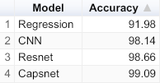

**Fig. 3**

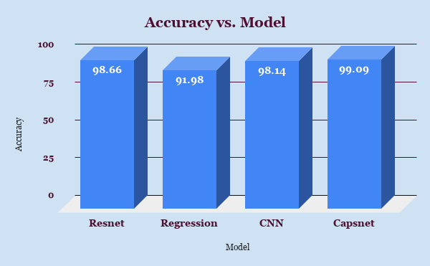

**Fig. 4**

## Resnet

The Resnet model for MNIST Dataset was trained for 7 epochs with a batch size of 32. The testing was performed on the model with batch size of 1000. The accuracy of Resnet model on MNIST dataset comes out to be 98.49%. The same model was then used for Fashion MNIST. The only change was in number of epochs and batch size while training. For MNIST increasing epochs were decreasing the accuracy which may be due to overfitting. In case of Fashion MNIST, the test data accuracy comes out to be 87.29% by increasing the number of epochs to 50. The batch size while training was kept to 1000.

## CNN

The CNN model was implemented as sequential model in Keras. For training, the batch size of 200 was used. The number of epochs were set to 100. The MNIST dataset gave the accuracy of 98.73% on testing dataset. The fashion MNIST dataset gave the accuracy of 87.38%. While running the fashion MNIST dataset the number of epochs and batch size of model was same as set for MNIST.

## Logistic regression

The logistic regression was implemented from Sklearn. The maximum number of iterations taken for the solvers to converge is set to 100 by default in fit method of Logistic regression. We set the iterations to 2000 otherwise the model failed to converge. The MNIST dataset gave the accuracy of 91.79% on testing dataset. The fashion MNIST gave the accuracy of 83.74% on the testing dataset. For Fashion MNIST also the iterations were set to 2000.

## Capsnet

As stated earlier, the deep network Capsnet is implemented from open source model of Xifeng Guo found on github.

The MNIST Dataset and fashion dataset are pre-processed and fed into this model. The accuracy on MNIST dataset comes out to be 99.07% and on Fashion MNIST, the accuracy comes out to be 86.76%. 5 epochs were used for both MNIST and Fashion MNIST Dataset for training Capsnet.

# CHAPTER 5

# CONCLUSION AND FUTURE SCOPE

**5.1 Conclusion**

This study provides insight into different state of the art models for image classification and their comparisons by testing the models on two datasets which include MNIST and Fashion MNIST. It has shown that deep learning networks like the Resnet, CNN and Capsnet shows high accuracy which are close to each other. The accuracy can be further increased by using deep neural networks with increase of computing power and training dataset. In future more advancement can be made in deep neural networks to explore more combinations of features. Pre-processing techniques can be further explored that can help in reducing the training time and increasing accuracy.

**5.2 Future scope**

* The connection of encoder and decoder was left. So it has to be completed.

The encoder and decoder contains Resnet, Downsampling layers and CNN layers build in Tensorflow as a non-sequential model.

All these layers are considered as tensor objects and the connection of encoder and decoder requires passing of these tensor objects through compression algorithm that requires data in bits and not tensor object.

* More datasets are to be used for comparing models for classification.

**Bibliography**

* <https://www.keycdn.com/support/what-is-image-compression>
* <https://en.wikipedia.org/wiki/Image_compression>
* <https://www.guru99.com/what-is-tensorflow.html>
* <https://en.wikipedia.org/wiki/TensorFlow>
* <https://www.tensorflow.org/about/>
* <https://towardsdatascience.com/an-overview-of-resnet-and-its-variants-5281e2f56035>
* <https://www.sciencedirect.com/topics/engineering/image-classification>
* <http://desktop.arcgis.com/en/arcmap/latest/extensions/spatial-analyst/image-classification/what-is-image-classification-.htm>
* <https://www.analyticsvidhya.com/blog/2019/01/build-image-classification-model-10-minutes/>
* <https://paperswithcode.com/sota/image-classification-on-mnist>
* <https://paperswithcode.com/sota/image-classification-on-cifar-10>
* <https://paperswithcode.com/sota/image-classification-on-imagenet>
* <https://arxiv.org/ftp/arxiv/papers/1805/1805.11195.pdf>
* <https://arxiv.org/abs/1904.12483>